1. 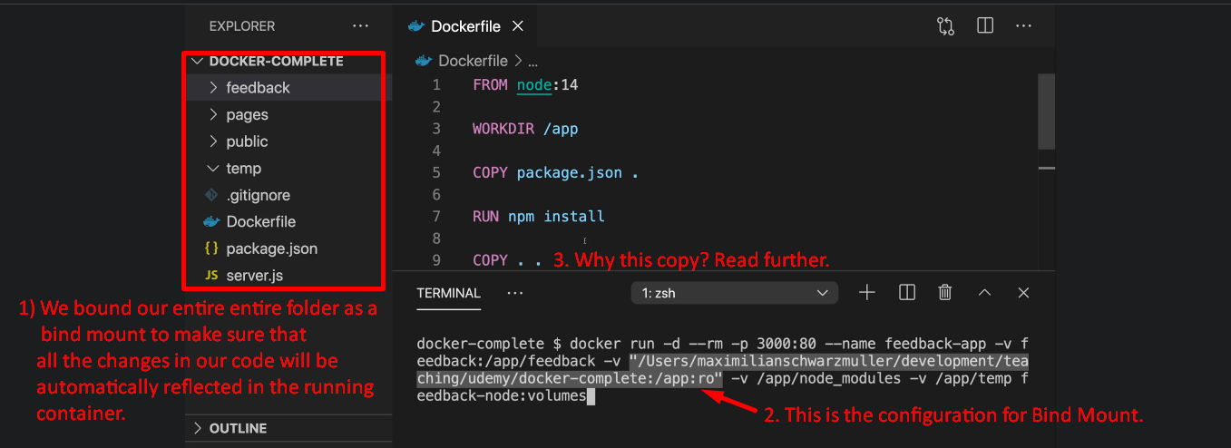
   1. Why do we copy the source code into the Dockerfile 🡺 **“copy . .”** even though we’re binding the entire source folder as a volume?
   2. We know “copy . .” command is run during docker build and “Bind Mount” is done later on which will replace all the copied code.
   3. 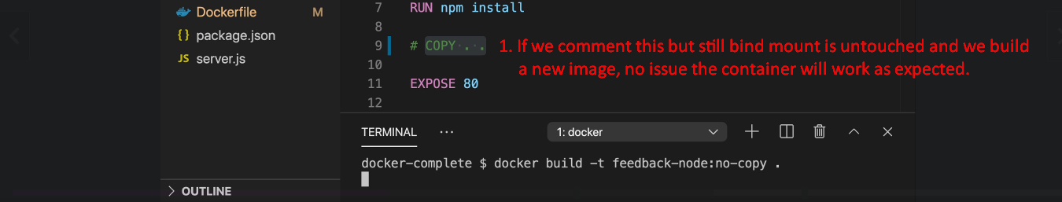
   4. But you must not forget one important point that is we use bind mount during development (like a developer is writing code and that developer wants to make live changes). Basically a developer wants to reflect the changes in the running container instantly.
   5. Once we are done with development and put the container on a server, we don’t run “docker run” command with “Bind Mount” but definitely we can use other volumes (anonymous and named).
   6. This is because once the container is running in production there is no connected source code which gets updated while it is running.   
      In production, we always want to have a snapshot of our code.   
      Text

      Description automatically generated
   7. So, the final take away is that if we want an image to create container for production then “copy . .” is needed.